**Assignment**

**CSA0805 – Python Programming**

|  |  |
| --- | --- |
| **Register Number** | **192372366** |
| **Name** | **Dasari.Navyasree** |

**Title: File search utility**

**Problem Statement: Write a Python program that searches for files matching a given pattern or criteria in a specified directory and its subdirectories, displaying the file paths and allowing users to open or manipulate the files.**

**Code:**

**import os**

**search = input("Enter the file u want to search from the currect directory: ")**

**data = os.system(f'tree ./ -af | grep "{search}" > out.txt')**

**if data == 0:**

**print("\n\nFiles:")**

**with open("out.txt", "r+") as file:**

**for i in file.readlines():**

**print(i.split(" ./")[1][:-1])**

**else:**

**print("Error")**

**Output Screen Shots:**

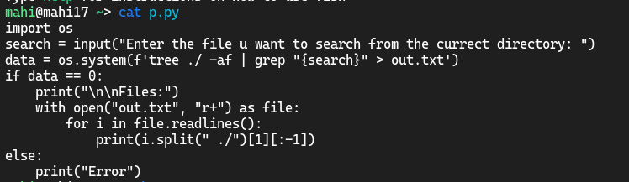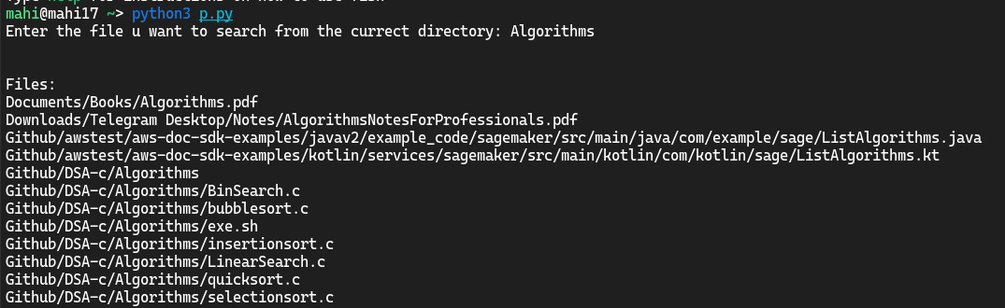

**Conclusion:**

**This script searches for files in the current directory and its subdirectories based on a user-provided search term. It uses the tree command with the -af flags to list all files and directories in a tree-like format, and grep to filter results that contain the search term. The filtered results are then redirected to out.txt.**